**Project** : **ELECTRICITY PRICE PREDICTION**

ADS_phase2

**Phase 2: Innovation**

In this phase you need to put your design into innovation to solve the problem. Explain in detail the complete steps that will be taken by you to put your design that you thought of in previous phase into transformation.

**ALGORITHMS OR STEPS TO PERFORM THE ELECTRICITY PRICE PREDICTION ON A GIVEN DATASET USING MACHINE LEARNING ALGORITHM**:

Performing electricity price prediction using data science typically involves a series of steps:

**1. Understanding the Problem:**

* **Define the Problem:**

Clearly define the problem you are trying to solve. Determine the specific aspects of electricity price prediction you want to focus on, such as hourly, daily, or monthly predictions.

**2. Data Collection and Exploration:**

* **Collect Data:**

Gather historical data on electricity prices. Include relevant features such as time of day, day of the week, weather conditions, demand, and any other factors that might influence prices.

* **Explore Data:**

Perform exploratory data analysis (EDA) to understand the data distribution, identify missing values, outliers, and correlations between features.

**3. Data Preprocessing:**

* **Handle Missing Data**: Impute or remove missing values in the dataset.
* **Feature Engineering:** Create new features that might enhance prediction accuracy. For example, derive features like moving averages, lag features, or time-based features.
* **Normalization/Scaling:**

Normalize or scale features to bring them within a similar range. Algorithms like Support Vector Machines and Neural Networks often benefit from scaled input features.

* **Train-Test Split:**

Split the dataset into training and testing sets. The training set is used to train the model, while the testing set is used to evaluate its performance.

**4. Feature Selection:**

* **Select Relevant Features:** Use techniques like feature importance from tree-based models or correlation analysis to select the most relevant features for prediction.

**5. Model Selection:**

* **Choose Algorithms:** Experiment with different algorithms such as Linear Regression, Decision Trees, Random Forest, Gradient Boosting, Neural Networks, or Time Series models (like ARIMA or SARIMA) to find the best-performing one.
* **Hyperparameter Tuning:** Use techniques like grid search or random search to find the best hyperparameters for your chosen algorithms.

**6. Model Training:**

* **Train the Model:** Train the selected model(s) on the training dataset using the chosen algorithm and hyperparameters.

**7. Model Evaluation:**

* **Evaluate the Model:** Use evaluation metrics such as Mean Absolute Error (MAE), Mean Squared Error (MSE), Root Mean Squared Error (RMSE), or R-squared to assess the model's performance on the test dataset.

**Visualize Results:** Visualize the predicted prices against the actual prices to understand how well the model is performing.

**8. Fine-Tuning and Optimization:**

* **Iterate:** If the model performance is not satisfactory, iterate through the process by refining features, trying different algorithms, or collecting additional data.

**9. Deployment:**

* **Deploy the Model:** Once you have a satisfactory model, deploy it to a production environment where it can be used to make predictions on new, unseen data.

**10. Monitoring and Maintenance:**

* **Monitor Performance:** Continuously monitor the model's performance in the production environment. If the performance degrades over time, retrain the model with fresh data.
* **Maintenance:** Update the model periodically to adapt to changing patterns in the electricity market.

Remember, the choice of algorithms and techniques may vary based on the nature of the dataset and the specific requirements of your prediction problem. It's essential to experiment and iterate to find the best combination of features, algorithms, and hyperparameters for your electricity price prediction task.

Top of Form

**Hardware Resources**:

* **Computing Power:**

For small to medium-sized datasets and basic algorithms, a standard multi-core CPU can be sufficient.

For large datasets and complex machine learning models, you may need high-performance CPUs (such as Intel Core i9, AMD Ryzen 9) or even server-grade CPUs (such as Intel Xeon) with multiple cores and threads.

* **Memory (RAM**):

Sufficient RAM is crucial for handling large datasets. At least 16 GB of RAM is recommended for most data science tasks. For more extensive datasets and complex models, 32 GB or more may be necessary.

* **Storage:**

SSDs (Solid State Drives) are preferred over traditional HDDs (Hard Disk Drives) because they provide faster read/write speeds, which can significantly improve data loading and model training times.

* **GPU (Graphics Processing Unit):**

GPUs, especially high-end ones like NVIDIA GeForce RTX or NVIDIA Tesla, are essential for accelerating deep learning algorithms. Many machine learning libraries, like TensorFlow and PyTorch, are optimized for GPU usage, significantly speeding up the training process for deep neural networks.

**Software Resources:**

* **Operating System:**

Most data science tools and libraries are platform-independent and work on Windows, macOS, and Linux. However, Linux distributions are often preferred for server deployments due to their stability and performance.

* **Programming Languages:**

Python: Python is the most popular language for data science. Libraries like Pandas, NumPy, Scikit-Learn, and TensorFlow/PyTorch for deep learning are commonly used.

R: R is another statistical computing language used for data analysis and visualization.

* **Integrated Development Environment (IDE):**

Jupyter Notebook: Jupyter provides an interactive environment for running code, visualizing data, and documenting the entire analysis process.

* **PyCharm, Visual Studio Code:**

These are powerful IDEs for Python development, offering features like code completion, debugging, and version control integration.

* **Database Management Systems:**

SQL Databases If your dataset is stored in a relational database, knowledge of SQL (Structured Query Language) and database management systems like MySQL, PostgreSQL, or SQLite is essential.

* **NoSQL Databases:**

For handling unstructured or semi-structured data, knowledge of NoSQL databases like MongoDB or Cassandra might be necessary.

**Machine Learning Libraries:**

* **Scikit-Learn:** A popular machine learning library for classical machine learning algorithms.
* **TensorFlow, PyTorch:** Deep learning libraries that provide tools for building and training neural networks.
* **Big Data Tools:**

Apache Hadoop, Apache Spark: If dealing with massive datasets, these tools can distribute data processing tasks across a cluster of computers.

* **Apache Kafka:** Used for real-time data streaming and processing.]

**Version Control:**

* **Git:**

Version control system for tracking changes in the codebase, collaborating with other developers, and maintaining code integrity.

* **Containerization and Orchestration:**

Docker Containerization tool used to package applications and their dependencies into containers for easier deployment.

* **Kubernetes:**

Orchestration tool for automating the deployment, scaling, and management of containerized applications.

Depending on the scale and complexity of your electricity price prediction project, you may need to invest in cloud-based services like AWS, Google Cloud Platform, or Azure, which offer scalable computing resources and managed services tailored for data science tasks.

**HARDWARE SPECIFICATION:**

**Small to Medium-Sized Projects:**

* CPU**:** Multi-core processor (e.g., Intel Core i5 or AMD Ryzen 5)
* RAM: 8 GB or more
* Storage: SSD with at least 256 GB capacity for faster data access
* GPU: Not necessary for basic models

**Medium to Large-Sized Projects:**

* CPU: High-performance multi-core processor (e.g., Intel Core i7 or AMD Ryzen 7)
* RAM: 16 GB or more
* Storage: SSD with 512 GB or 1 TB capacity for faster data access

**Large-Scale or Deep Learning Projects:**

* CPU: High-end multi-core processor (e.g., Intel Core i9 or AMD Ryzen9)
* RAM: 32 GB or more
* Storage: NVMe SSD with 1 TB or more capacity for faster data access For truly large-scale projects dealing with big data, you might need a cluster of machines. In this case, cloud-based solutions like AWS, Google Cloud Platform, or Azure with scalable computing resources can be more practical. These platforms offer services like Amazon EMR, Google Cloud Dataproc, or Azure HDInsight.

**SOFTWARE SPECIFICATION:**

* Processor : intel 3rd generation
* Softwares: python 3.6 or high version
* IDE: Pycharm
* Framework: Flash

**Programming Languages:**

* **Python:** Python is a popular choice for data science tasks due to its extensive libraries and frameworks. Libraries like NumPy, Pandas, Scikit-Learn, and TensorFlow/PyTorch provide robust support for data manipulation, analysis, and machine learning.
* **R:** R is another statistical computing language widely used for data analysis and visualization, especially in academic and research settings.

**Integrated Development Environments (IDEs):**

* **Jupyter Notebook:** Jupyter provides an interactive environment for running code, visualizing data, and documenting the analysis process. It supports multiple languages, including completion, debugging, and version control integration.

**Machine Learning Libraries:**

* **Scikit-Learn**: A popular machine learning library in Python that provides simple and efficient tools for data mining and data analysis. It includes various algorithms for regression, classification, and clustering.
* **TensorFlow, PyTorch:** Deep learning libraries that provide tools for building and training neural networks. TensorFlow and PyTorch are especially useful for complex tasks involving deep learning.

**FLOWCHART:**

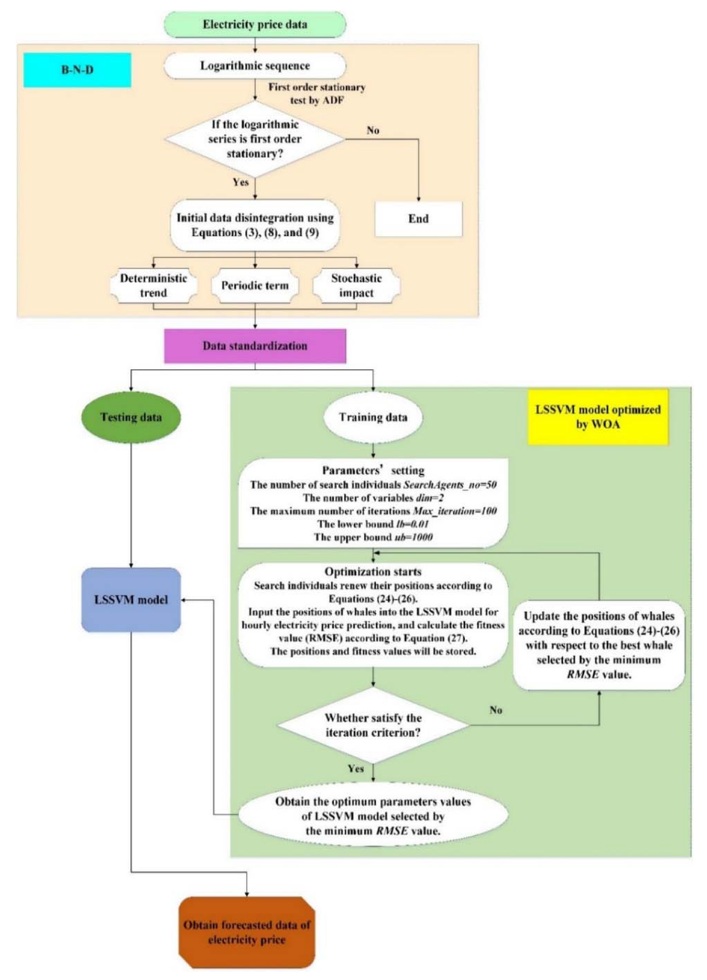

**Experiment Results:**

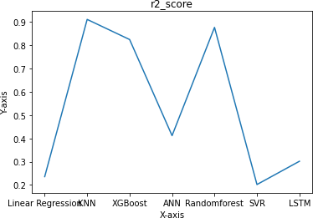

KNN result :

